Software Requirements Specification
Athena

First Draft: February 8, 2010
Final Revision: February 16, 2010

Gregory LeBlanc
Norman Maclennan
Stephen Failla
1 Introduction iii
1.1 Purpose of this Document iii
1.2 Scope of the Development Project iv
1.2.1 Project Name iv
1.2.2 Functionality Overview iv
1.2.3 Benefits iv
1.3 Definitions, Acronyms and Abbreviations iv
1.4 References iv
1.5 Document Overview iv
2 General Description v
2.1 User Characteristics v
2.2 Product Perspective v
2.3 Overview of Functional Requirements v
2.3.1. Data Communication v
2.3.2 Communication Interface v
2.3.3. Interface Menus vi
2.4 Overview of Data Requirements vii
2.5 General Constraints, Assumptions, Dependencies, Guidelines vii
2.5.1 Constraints vii
2.5.2 Assumptions viii
2.5.3 Dependencies viii
2.5.4 Guidelines viii
2.6 User View of Product Use viii
Figure 2.6.1 ix
Figure 2.6.2 ix
Figure 2.6.3 x
3. SPECIFIC REQUIREMENTS x
3.1 External Interface Requirements x
3.1.1 User Interfaces x
3.1.2 Hardware Interfaces xi
3.1.3 Software Interfaces xi
3.1.4 Communication Interfaces xi
3.2 Detailed Description of Functional Requirements xi
3.2.1 Template for describing functional requirements xi
3.2.2 Communication Interface xi
3.2.3 Interface Menus xiv
3.2.3.1 File Drop-down Menu xiv
3.3 Performance Requirements xvi
3.4 Quality Attributes xvii
3.4.1 Security xvii
3.4.2 Reliability xvii
3.4.3 Availability xvii
3.4.4 Maintainability xvii
3.4.5 Portability xvii
4 Other requirements xvii
4.1 Packaging Requirements xvii
5 Use Cases xvii
Appendix A xix
Appendix B xxi

1 Introduction

1.1 Purpose of this Document
This Software Requirements Specification defines and describes the overall function and performance of Athena. This specification shall identify the functional, performance, development, and user requirements for the Athena application.

1.2 Scope of the Development Project

1.2.1 Project Name
Athena

1.2.2 Functionality Overview
The Athena program is a standalone Java-based communication application that will allow users to exchange encrypted instant messages via a secure central server. Athena will have the ability to process all encrypted messages in real time. Athena will have a constant connection to a database, and users will be able to observe the status of other users through a friend list in the main window of the application.
Athena will also have the ability to send encrypted files between online users, and exchange encrypted emails through a dedicated mail server on the Athena domain. Athena will give users the option to create a user name, password, and encryption key pair for data security. This option will be available through the Athena web site as well as the program's interface.
The general interface look and feel of Athena will be customizable to the user. Basic appearance and layout characteristics will have multiple options for active users.

1.2.3 Benefits
Athena users will have the protection of RSA encryption during all online messaging, email, and file transfer sessions. Athena's level of encryption will provide substantial data protection and confidentiality for all users. The security aspects of Athena will not complicate the user experience. The interface of Athena will remain simple and intuitive.

1.3 Definitions, Acronyms and Abbreviations
* See Appendix A

1.4 References
(n.d.). Retrieved Feb 2010, from Wikipedia:
http://wikipedia.org
AthenaChat.org. (n.d.). Retrieved Jan 2010, from AthenaChat:
http://athenachat.org
Deligiannidis, L.
(2009, Aug). Network Security.
How To Safely Store a Password. (n.d.). Retrieved
Feb 2010, from Codahale: http://codahale.com/how-to-safely-store-a-password/
http://github.com . (n.d.). Retrieved Jan 2010, from GitHub:
http://github.com/maclennann/Athena-Chat
Java SE5 API. (n.d.). Retrieved Jan 2010, from Java Sun:
http://java.sun.com/j2se/1.5.0/docs/api/

1.5 Document Overview
Section 1 of this document identifies the purpose and scope of the software and the document and lists all definitions, acronyms, and references. Section 2 is an overview of the description of application characteristics, requirements, and basic rationale for client use and experience. Section 3 contains a more detailed analysis of the functional, data, and hardware requirements and constraints. Data flow and relational concept diagrams will also be included in Section 3.

2 General Description

2.1 User Characteristics
Aside from basic desktop experience with a computer, no specific knowledge, skill, or training is required on the part of the user prior to using this product. The user shall not be expected to learn or memorize any commands or controls prior to installing and using this application. Commands, controls, and user preferences shall be available through menus, tips, and help screens within the application. Users shall be guided through initial setup process via menus and screen prompts. Users shall be ensured an encrypted connection before online communication can begin.

2.2 Product Perspective
The software described in this specification shall be a standalone application that requires the Java Runtime Environment (Java Standard Edition 5 or greater) to run. The application shall identify any existing Java environment upon install, and install the required environment if it doesn't exist on the target system. The software shall use the Java Swing API to generate and present the GUI. The application shall communicate with a dedicated server that is hosted by the Athena domain as an external interface. Internet connectivity shall be required by the user to create a successful connection with the application's host server. The application shall provide support and functonality for all common hardware setups.
If the software is obtained for open-source development purposes, a connection to the host server shall not be necessary. The source code for the server application shall be able to run in a Java development environment separately and simultaneously with the client application.

2.3 Overview of Functional Requirements
The functionality of the software can be categorized into three major sections. These overview sections correspond to the detailed requirements in Section 3.2.

2.3.1. Data Communication
The software shall be able to send and receive fully encrypted data in multiple formats. The software shall permit the exchange of plaintext messages, emails, and files through an encrypted connection. The application shall allow users to send and receive emails from a current session email address or a permanent address from an external domain. The software shall permit encrypted file transfer of local files on the user's computer or network.

2.3.2 Communication Interface
The software shall provide an intuitive user interface for efficient data communication and menu navigation. The interface shall consist of two major windows:

2.3.2.1 Offline Interface
The offline interface shall provide the user with the opportunity to log in to the Athena database and create a secure connection to the server to initiate an online session. The software shall provide a text location to enter a user name and password, and a selection of buttons that shall allow the user to either proceed with login or exit the application. The user shall be notified if any login information is invalid. The offline interface shall also provide an option to generate a new user name and password in the Athena database if necessary or desired. If a user name or password has been forgotten, an option will be available to send the login information to a specified email address pending verification.

2.3.2.2 Online Interface
The online interface shall provide the user with a selection of options and settings during an online session. This interface shall display a ""friend list," a customizable list that contains other known Athena users that the current session holder has added as friends. This list shall provide buttons for adding and removing friends from the list and creating groups within the list.
The interface shall also display text areas for displaying plaintext messages that are sent and received through the established connection. The interface window shall allow for customizable font style and color through a selection of buttons.
The application shall provide an interface method of initiating a file transfer via a visible button.
The user shall be able to begin or end an encrypted communication session with one or more online users. The software shall organize the individual communication windows in a tabbed format. The interface window shall also allow the user to scroll through the text communication area in both the horizontal and vertical directions. The software shall also have the option to play a sound upon sending or receiving data in a session.
The online interface will feature a menu bar with additional options and settings (See 2.3.3 for menu functionality overview).

2.3.3. Interface Menus
The online interface shall provide a system of menus for extensive settings and options. The interface menu will consist of five drop-down menus:

2.3.3.1 File Drop-down Menu
The file menu shall allow the online user to disconnect from a current session, display a status message, send a one-time-address email, send a permanent-address email, or exit the application.

2.3.3.2 Edit Drop-down Menu
The edit menu shall allow the online user to edit application preferences or change current password.

2.3.3.3 View Drop-down Menu
The view menu shall allow the online user to view the inbox of the encrypted email address associated with the current session.

2.3.3.4 Encryption Drop-down Menu
The encryption menu shall allow the online user to generate a new key pair or export the current key pair.

2.3.3.5 Help Drop-down Menu
The help menu shall allow the online user to select an About tab that displays information and links about the software application.

2.4 Overview of Data Requirements
The application shall prompt the user for a new user name and password upon successful installation. The user shall be able to input a user name and password that will be stored in an online database. The user will not have access or viewing permissions of the database, but the user name and password that is created will be added to the database and the user will be notified upon successful account creation.
The application shall display all text data exchanged in online sessions. Text data between users shall be displayed in a plaintext communication area on a session tab. The user shall be able to view sent and received data between other users. If the user is exchanging data with multiple other users, text data shall be displayed in exclusive tabbed windows corresponding to each user. All visible data shall be in decrypted format. User shall be able to view sent and received emails in decrypted format. No data shall be displayed in encrypted format.
No data shall be stored in the database or system after user terminates the secure connection. Sent and received text data shall be stored on the screen during an online session, and emails shall be stored in a temporary online mailbox. After user logs off, all text and email data shall be erased and unrecoverable.
When exporting an encryption key pair, a file with key pair information shall be saved to a specified location on the user's local storage device. A user folder containing configuration files shall also be generated upon installation. This folder shall include a saved text file of the user's buddy list from the most recent session. Other configuration files will be edited from the online interface menus.

2.5 General Constraints, Assumptions, Dependencies, Guidelines

2.5.1 Constraints
The constraints for the software application shall be assessed in two parts:

2.5.1.1 Hardware
The application does not have any known hardware constraints or dependencies as of current release.

2.5.1.2 Software
The application must have an active internet connection in order to initiate an online session with the server. The application can be opened in offline mode, but no online features will be available, and any attempts to log into the server will fail until an internet connection is established.
The application may not function properly if certain corporate-level firewalls attempt to block attempted server connections. This is an unlikely event, but if a connection cannot be established, confirm that a multi-layer firewall is not restricting use.
The application may not be able to export an encryption key pair to a location on the user computer if certain file or folder permissions have been established by a company administration or otherwise. If a permission error occurs while attempting to export a key pair, confirm that system permissions are not restricting use.

2.5.2 Assumptions
It is assumed that the encryption and hashing methods and algorithms used for creating secure connections within the application meet current and updated encryption standards and guidelines.
It is assumed that the requirements described in this document have different levels of priority. It is assumed that certain low-priority requirements may be postponed to ensure timely and successful completion of high-priority requirements. Requirements should only be removed or postponed pending agreement with customers and clients. While there is currently no documentation of requirement priority, it is assumed that a requirement will not be removed unless it can be clearly justified as having no dependencies or connections to high-priority requirements.

2.5.3 Dependencies
The application requires the Java Runtime Environment to be installed on the computer of the user trying to run the application. Java Standard Edition 5 or greater is recommended for optimal performance. During install, application will check for an active version of Java, and install a working version automatically if one is not found upon installation.
This application is not dependent on any other hardware or software after the Java Runtime Environment has been installed.

2.5.4 Guidelines
This application does not have any specific guidelines for use.

2.6 User View of Product Use
Figure 2.6.1 shows the prototype layout of Athena. Designed with one window in mind, the buddy list is in the same window as the messages.
Figure 2.6.2 Shows a marked prototype layout for easier understanding.
Figure 2.6.3 shows a high level encrypted message transfer.

Figure 2.6.1
See Appendix B

Figure 2.6.2
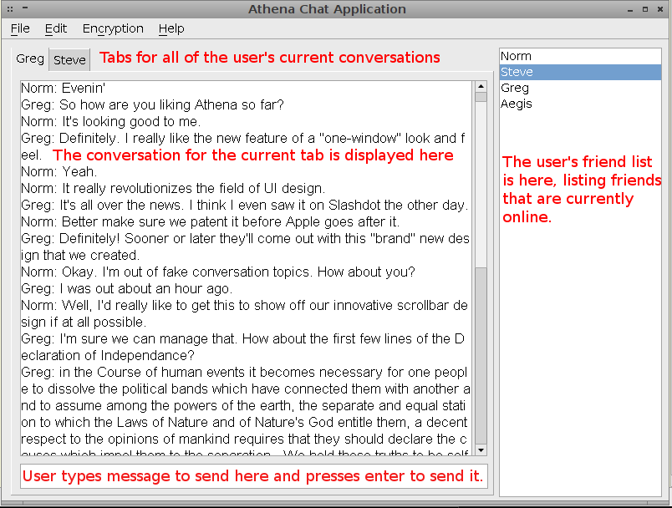
Above is a sample conversation between two users. The buddy list and the other components in the window are there as well.

Figure 2.6.3
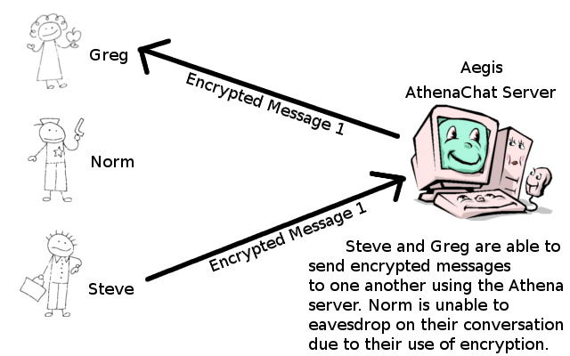
Above is a diagram depicting a sample message transaction.

3. Specific Requirements

3.1 External Interface Requirements

3.1.1 User Interfaces
All interaction between the user and the software shall be supported by the software GUI. The interface of the application will provide either an offline or online interface to the user depending on connection status. When creating an account, the offline interface will provide visual notification to the user if an account already exists. When logging in to the server, if the user name and password combination entered is incorrect, the user will be visually notified. When using message tabs in the online interface, the user will be provided with the ability to scroll through text communication data that can not fit in the message tab window space. The online interface will provide the user with a separate window to compose and manipulate received and sent emails. When a user attempts to disconnect from an online session, visual notification will be displayed confirming this choice. The online interface will also provide a separate settings window when a user chooses to edit application preferences during a session. If at any time a connection is refused or interrupted, the user will be visually notified of the connection error and a selection of possible causes will be displayed. The GUI will also provide the user with individual status windows while exporting or generating encryption key pairs. Both the offline and online interfaces will have the ability to display a help window with important product information.

3.1.2 Hardware Interfaces
There are no external hardware interface requirements for the software.

3.1.3 Software Interfaces
The software will have the ability to use the operating system file management system to locate and select files when initiating a file transfer during a session. There are no known platform or portability requirements for the software.

3.1.4 Communication Interfaces
The software shall have the ability to export encryption key pairs in a common format that is compatible with other encryption software applications using the same method of encryption

3.2 Detailed Description of Functional Requirements

3.2.1 Template for describing functional requirements
Here lies the template for the proceeding section on the detailed functional requirements.
3.2.x Overall Component
3.2.x.x Specific Interface
Component Name | Purpose | Inputs | Process

3.2.2 Communication Interface

3.2.2.1 Offline Interface
Component Name | Purpose | Inputs | Processing | Outputs
Create Account | To be able to connect to Athena | Username, password, email, age | Validity checks on the username and password and age, password requirements | Information will be entered into the database. One record per user. Any error messages will be displayed in a pop-up style winow
User Name Entry | Username is entered here before logging in | User name | Username is sent to the database to see if it is registered. If not, the user will be notified to register. | If found, and password is correct the user gets access to Athena
Password Entry | Password is entered here before logging in | Password | Password is sent (hashed) to the database to see if it matches accordingly. If not, the user will be notified to try again. After 5 tries the user is locked out for a predetermined amount of time | When matched, the user gets access to Athena
Forgot Password | If user forgets password - new password can be created | Username, email | Email is sent to user, they will be redirected to AthenaChat.org where they will create a new password | The new password is created, added to the database
Connect | This initiates the connection with the server | The username and password from the above fields, respectively | The information is sent to the server which allows the client to login | User is logged in to Athena
Exit | Exit Athena | None | None | Athena is closed , connection is closed

3.2.2.2 Online Interface
Component Name | Purpose | Inputs | Processing | Outputs
Send Message | To contact other users | The message the user wants to send | Validity checks will be placed upon the message before it is sent. The message will be encrypted using the user's private key before it is sent | Message sent to the recipient
Receive Message | To receive messages from another user | The message is displayed in the user's window | Validity checks will be placed upon the received message before it is displayed. The incoming message will be decrypted using the sender's public key | The decrypted message will be displayed in the user's window
Buddy list | To view the user's available "friends" | List is generated from the buddy list file on the user's computer | Logic is applied to verify that the users on the "Buddy list" are online. | The list will be displayed in a section of the "Online Interface"
View User's Status | To view a friend's current online status | The buddy list will have the user's listed. | Validation will be in place to make sure the user's status's are accurate and real time | Their statuses will be displayed below their respective name in the Buddy list
Add Friend | Adding a user to his/her Buddy list. This enables encrypted communication | The username the user wishes to add | Validation will check to see if the user is an actual user of Athena | The user is added to the Buddy list
Remove Friend | Remove another user from the user's friend list | Username of friend to remove | An entry will be removed from the XML file containing a user's friend | The user will see the friend no longer appears in their friend list
Add Group | Allow users to organize friend list in a way that makes sense to them | Group name, friend(s) to add to group | The user's friend list XML will be updated, placing the specified friends into the newly created group | The user's friend list will update to reflect the new group and moved friends
Remove Group | Allow users to organize friend list in a way that makes sense to them | Group to remove | The user's friend list XML file will be updated, removing the group and placing the members that were in the group in to a generic group | The user's friend list will update to reflect the changes
New Message Tab | To allow user's to have conversations with different users, keeping them seperate | User to talk to | A new tab is created inside the user's window, associated with the recipient they chose | The user sees a new tab appear in their window, titled with the user they want to talk to. They are able to begin the conversation.
Close Message Tab | Allows the user to keep their conversations organized by closing conversations he no longer needs to see | The user clicks on a small button in the tab title | The tab is removed from the window, and the object is destroyed | The user sees the tab disappear from their window
Send File | Allows the user to send an encrypted file to a specified recipient | The user chooses the recipient and the file to send | The file is broken into chunks, a hash of the file is created, and it is encrypted before being sent to he recipient, where it is decrypted and put back together. | The user sees a message indicating that the file was successfully transferred.
Text Font Style | Allows the user to change the font style displayed by their conversation tab | Which font style they want to use | The font property of the text box in the current tab will be changed to reflect the user's choice | The font in their current tab will change to reflect their choice.
Text Font Color | Allows the user to change the font color displayed in the current conversation tab | Which color they want to use | The font color of the current text box will be update to reflect the user's choice | The font color in the current tab will change to reflect the user's choice
Text Font Size | Allows the user to change the size of the font displayed in the current conversation tab | Which size they want to make the font | The font size property of the current text box will be changed to fit the user's choice | The user will see the font in the current tab change to reflect their choice
Text View Area | To show the user's conversation | The input is taken from the text communication area, as well as incoming messages from other users | Messages are added to the text view area as they are sent by the current user or received from other users | The messages for the current conversation are displayed
Text Scroll Vertical | Allows the user to scroll through a long conversation | There is no input needed from the user | The current conversation is placed into a scrolling pane that the user can look through | The user can examine different parts of the message

3.2.3 Interface Menus

3.2.3.1 File Drop-down Menu
Component Name | Purpose | Inputs | Processing | Outputs
Disconnect | Terminate current connection with server | None | After confirmation, client socket connection with server is closed and session data is erased | User is returned to the offline interface
Status Message | Notify users on contact list of current tasks or locations | Custom text entered by the user to be displayed as a status | The text will be verified for length and appropriately formatted content | The validated text status is displayed under the user's name in the buddy list of all online users
Send One-time-address Email | Send an email to a temporary session address of an online buddy | Desired data contents to be sent | Email contents will be verified for length and format and data will be encrypted before leaving client | Encrypted email will be decrypted and displayed in recepient inbox in readable format
Send Permanent-address Email | Send an email to a permanent domain address of an online buddy | Desired data contents to be sen | Email contents will be verified for length and format and data will be encrypted before leaving client | Encrypted email will be decrypted and displayed in recepient inbox in readable format
Exit | Close application completely | None | Upon confirmation, client will be disconnected from server and any message tabs will be erased | All application windows and interfaces will close

3.2.3.2 Edit Drop-down Menu
Component Name | Purpose | Inputs | Processing | Outputs
Settings and Preferences | Edit application behavior preferences and visual/audio settings | Selection of buttons to adjust corresponding settings and preferences | The corresponding setting that is adjusted by the user will be processed by the application | All changes made will take effect upon confirmation and be visible to the user
Change Password | Reset or change current account password for security or personal purposes | Old password, new password, new password confirmation | Old password will be verified for validity, new password and confirmation will be verified for appropriate length and format | If any data is incorrect, user will receive a message to retry password change. Otherwise, user will receive successful confirmation message.

3.2.3.3 View Drop-down Menu
Component Name | Purpose | Inputs | Processing | Outputs
Session Inbox | View temporary session email mailbox | None | User's session inbox will be accessed, and any encrypted files will be decrypted for viewing | Any emails that were sent or received during active session will be displayed
View Buddy list | Allow user to hide or show buddy list | Check-box option | Status of box will be confirmed by application and view setting will be applied | If box is checked, user's buddy list will be visible in online window. Otherwise, buddy list will be hidden.

3.2.3.4 Encryption Drop-down Menu
Component Name | Purpose | Inputs | Processing | Outputs
Generate New Encryption Key Pair | Create new encryption key if current key is compromised or unreliable | Key password | Key password is used to generate a new private and public key pair based on encryption algorithm | Confirmation message is displayed notifying user of successful key pair generation
Export Current Key Pair | Export current encryption key for use with other encryption applications | None | Encryption key file will be written to a file in the user application folder | Confirmation message will be displayed notifying user of location of exported file

3.2.3.5 Help Drop-down Menu
Component Name | Purpose |  | Inputs | Processing | Outputs
About Athena | Access useful information from product web site | Option to click on URL links to view web site |  | Application will identify default browser and send product link to the browser | Browser will load link in new window and display product help page on the screen

3.3 Performance Requirements
Performance requirements have not yet been established for the software.

3.4 Quality Attributes

3.4.1 Security
The keys should not be susceptible to compromise. With the use of the international standards of encryption the keys and hashes should not be able to be spoofed or susceptible to a MITM (Man in the Middle) attack.

3.4.2 Reliability
Downtime will be kept to a minimum. There will be weekly serverdown time for database maintenance and system patching. The website (http://athenachat.org) will have constant updates and news feeds so users can get information. Application will have a system of recoverable error handling for common errors

3.4.3 Availability
Athena will be accessible from anywhere in the world.

3.4.4 Maintainability
Athena will have nightly builds along with timely patches and critical bug fixes. The source code files shall have comments concerning date of last change/revision to allow easier future modification and open source modulation

3.4.5 Portability
Athena will be able to run on the following Operating Systems:
Windows
Linux
Mac OSX

4 Other requirements

4.1 Packaging Requirements
The software will be packaged as a single installation file. All source code and user documentation will be provided in the package file. When the package file is installed and extracted, a set of files will be created in an application folder that will include the core Athena files (Athena.exe), configuration files (Athena.conf) and user based files (buddylist.xml). Uninstallation will be normally available through the host operating system.

5 Use Cases
Figure 5.1 High Level Data Flow Model for a simple message transfer
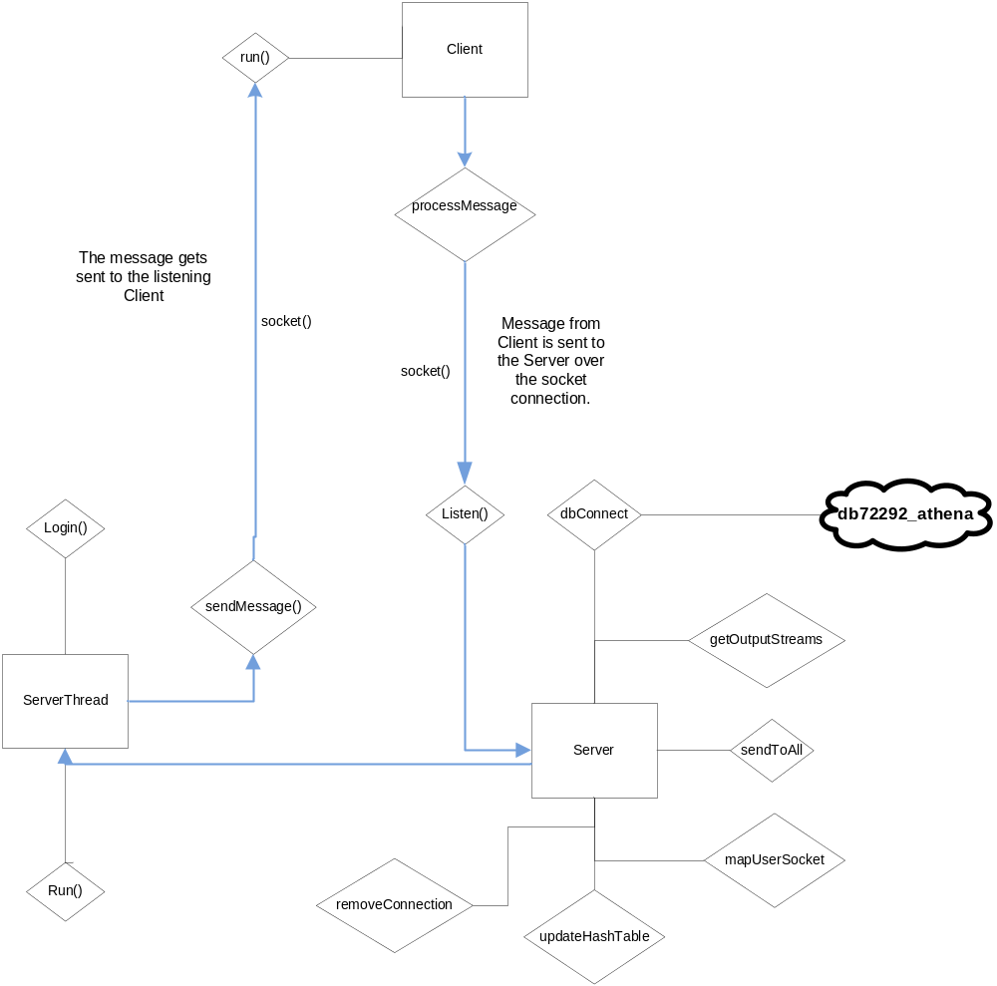
Figure 5.1 High Level Class Hierarchies
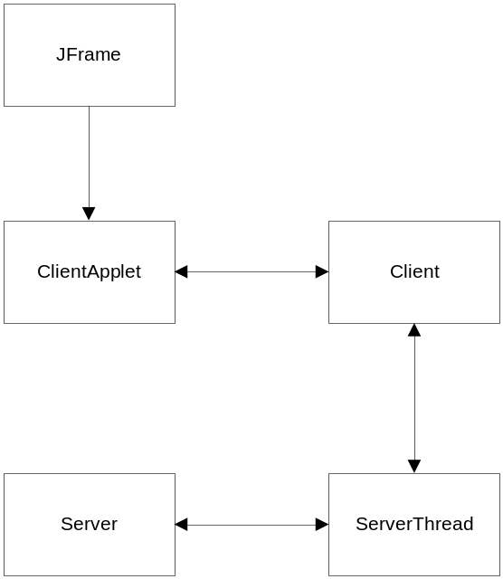

Appendix A
Advanced Encryption Standard (AES) | A method of encryption using symmetric keys. The same key is used to encrypt and decrypt the target message. This method is faster than RSA, but an agreement on a symmetric key must first be established.
Application | Application software is computer software designed to help the user to perform a singular or multiple related specific tasks. Such programs are also called software applications, applications or apps.
Application Programming Interface (API): | This is a public "interface" that allows software to interact with other software and users.
Central Processing Unit (CPU | The "brain" of the computer that executes the program's instructions, and does all of the calculations for the encryption algorithms.
Client-Server architecture | A common program architecture in which a user or users run a small "client" program which interacts with a main "server" to exchange information. The Internet is an example of a client-server architecture.
Compiler | A software application used to convert source code into machine language executable programs to be run by a computer.
Cross-platform | A program's to run on different Operating Systems or computer types. For example, a cross-platform program is able to run on both Windows and Macintosh computers.
Diffie-Hellman | A method of generating one-time-use encryption keys (eg. AES) secretively. Through the use of large prime numbers, users are able to agree upon and seperately generate the same key without ever communicating over an unsecure connection.
Encryption | A method of hiding or obscuring information, generally using a mathematical algorithm. This information can only be recovered using a secret password or key.
File Transfer | A way of moving or copying a file from one location to another.
Hashing | A "one-way" algorithm. This is similar to encryption, but not quite the same. A hashing algorithm will generate a unique string of characters of anything passed to it. These algorithms are designed to never generate the same string from different data, making it perfect for securely storing and checking passwords.
Java | An object-oriented programming language that allows programmers to create applications on any OS. Java uses a "Virtual Machine" to run it's programs in.
Java Virtual Machine (JVM) | Uses the java instructions generated by a Java compiler and translates them into machine code for execution. This makes java programs inherently cross-platform, because any java program will run on any computer capable of running the JVM.
Local-area Network (LAN): | A group of computers in a small physical area that are connected one another. LANs are smaller in scope than the Internet; the Internet is made up of a large group of interconnected LANs.
Machine language | Instructions a program executes at a very low level that allows the application to run.
Man-in-the-middle Attack (MITM): | A common vulnerability in communications infrastructures in which an attacker can capture messages from one endpoint, and, after capturing the information, transparently relay the information to the intended recipient.
Operating System (OS): | An interface between hardware and user, which is responsible for the management and coordination of activities and the sharing of the resources of a computer, that acts as a host for computing applications run on the machine.
Plaintext | A message or text that is unencrypted.
Random-access Memory (RAM): | When computer programs are run, or files are opened, they are loaded into the RAM for later access when it is needed.
Relational Database | A collection of tables used to organize specific information. A company may use a relational database to keep information on their employees and customers.
Rivest Shamir Adleman (RSA): | A method of encryption using a key pair comprised of a public and a private key. A message encrypted with the public key can only be decrypted with the private key, and vice-versa. This ensures confidentiality and represents a digital signature. The acronym references the names of the method's original designers.
Specific Hashing Algorithm 256 (SHA-256) | Part of the "SHA-2" family of hash algorithms

Appendix B
Figure 2.6.1
